[[FICCRISK-38609] Handle data missing issues in Rates EOD Limit Check reports - Horizon/Jira2](https://jira2.horizon.bankofamerica.com/browse/FICCRISK-38609)

“EOD Limit based check report” in UAT

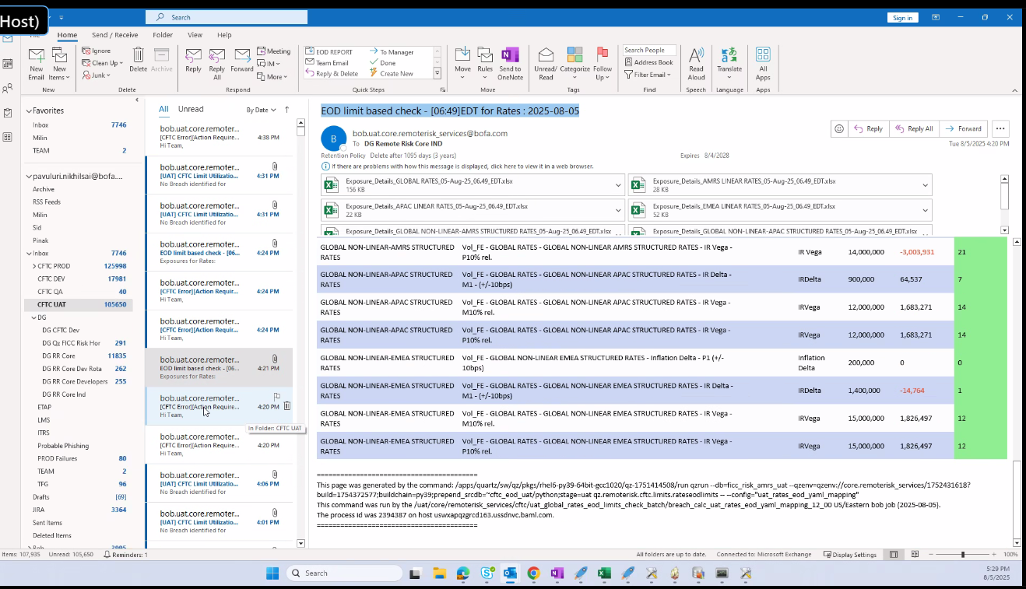

One alert for each VTD with the details of each of the measures missing

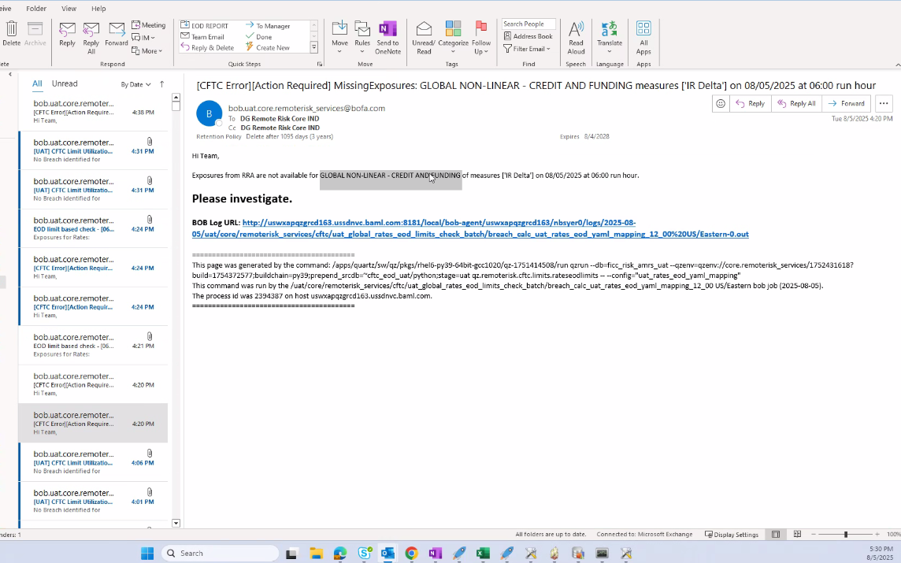

For the attachments in the EOD limit check report, all VTDs with at least one measure present must have an exposure details attachment

GNR – cirt and legacy two data sources (AMRS) – should not be duplicated and only three sources present

Both metrics for both sources

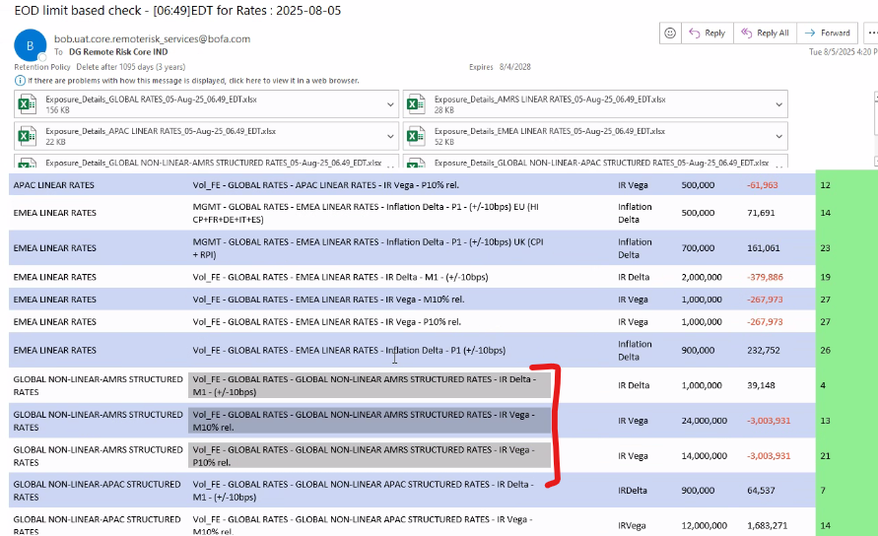

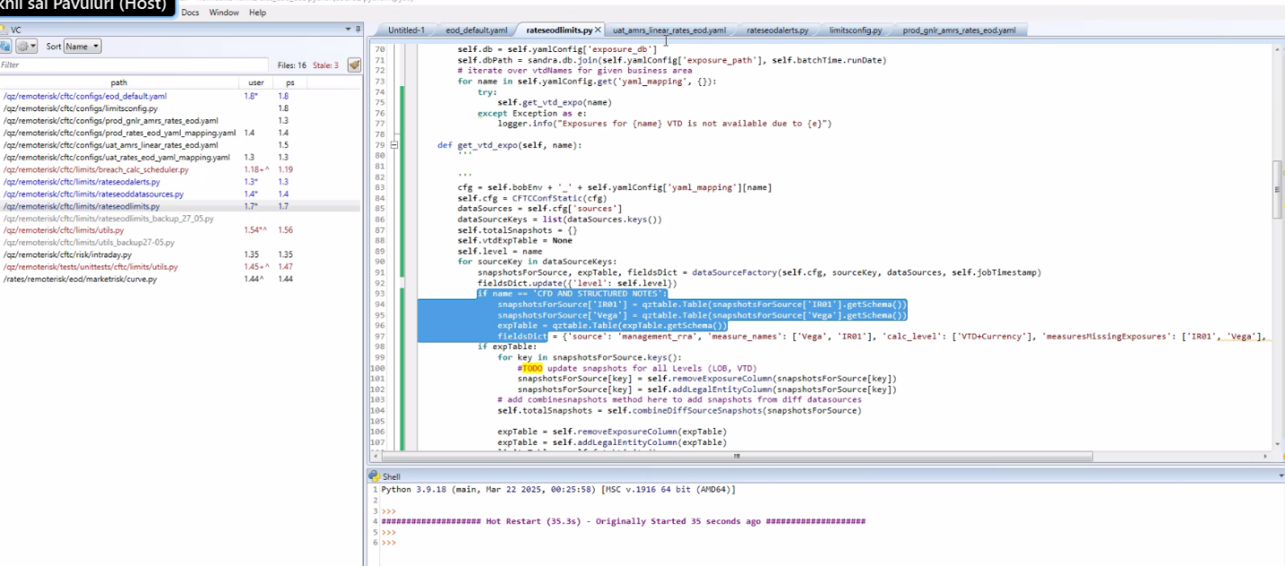

Order of VTDs:

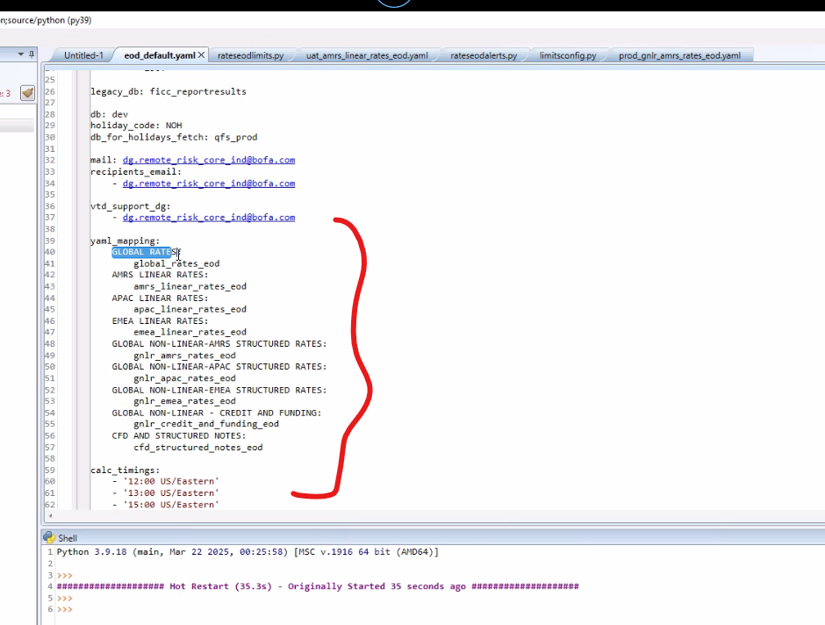

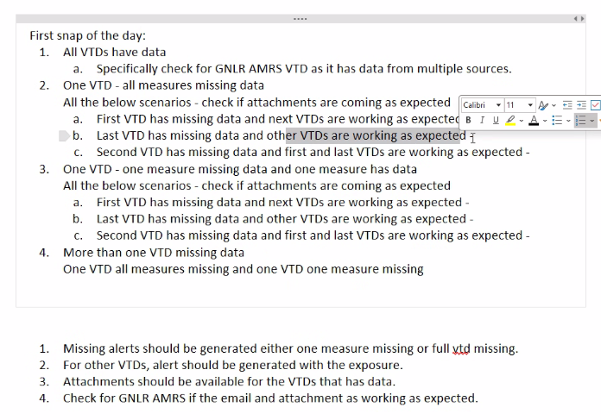

Second snap – repeat cases



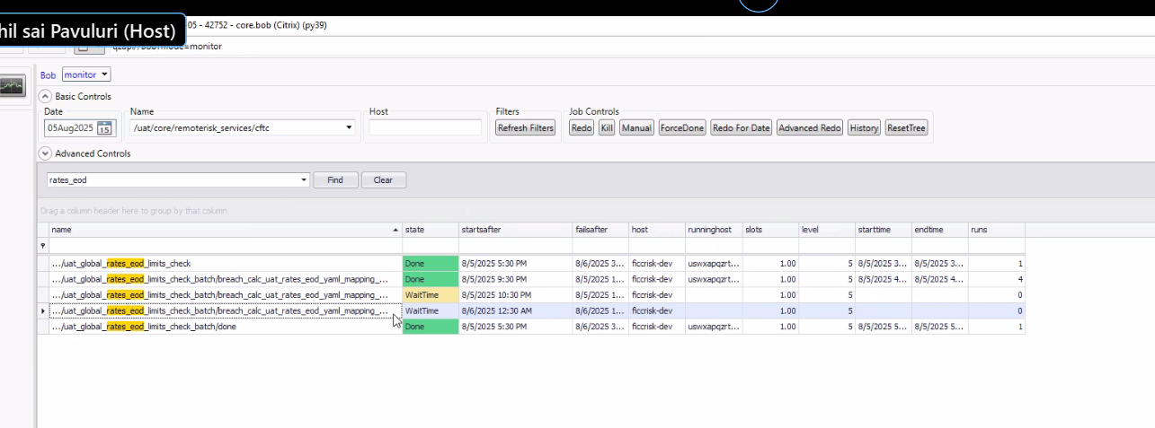

First snap before 9 30 , Second snap – last day cob

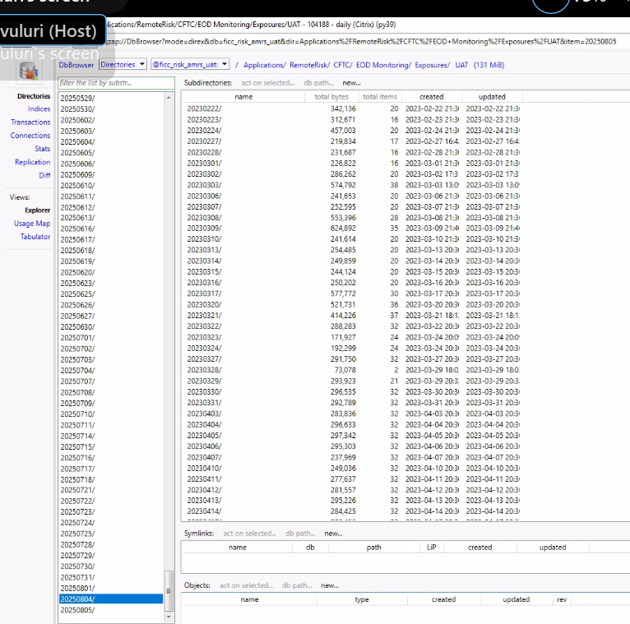

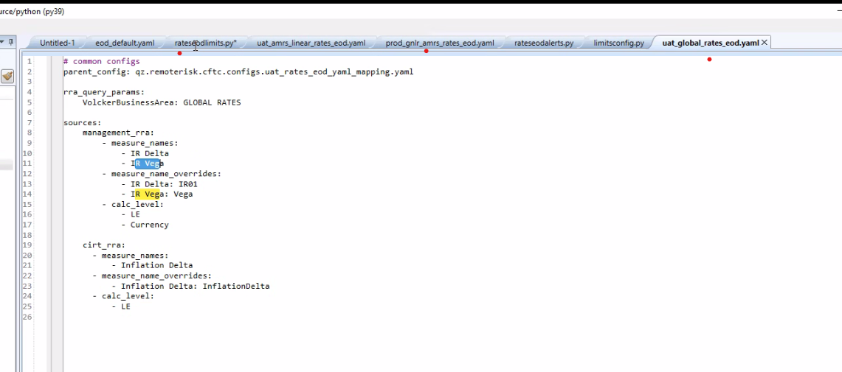

Go to the corresponding VTD’s yaml file and update the rateseodlimits script with the respective source and measure name

UPDATED SCENARIOS –

First snap of the day:

1. All VTDs have data
   1. Specifically check for GNLR AMRS VTD as it has data from multiple sources.
2. One VTD - all measures missing data

All the below scenarios - check if attachments are coming as expected – attachment for missing VTD shouldn’t be available

1. First VTD has missing data and next VTDs are working as expected
2. Last VTD has missing data and other VTDs are working as expected
3. Second VTD has missing data and first and last VTDs are working as expected
4. One VTD - one measure missing data and one measure has data

All the below scenarios - check if attachments are coming as expected – attachment for missing measure for VTD shouldn’t be available, but measure with exposure should be available.

1. First VTD has missing measure and next VTDs has full data
2. Last VTD has missing measure and other VTDs has full data
3. Second VTD has missing measure and first and last VTDs has full data
4. More than one VTD missing data

One VTD all measures missing and one VTD one measure missing data.

EVIDENCE –

1. **All VTDs have data**

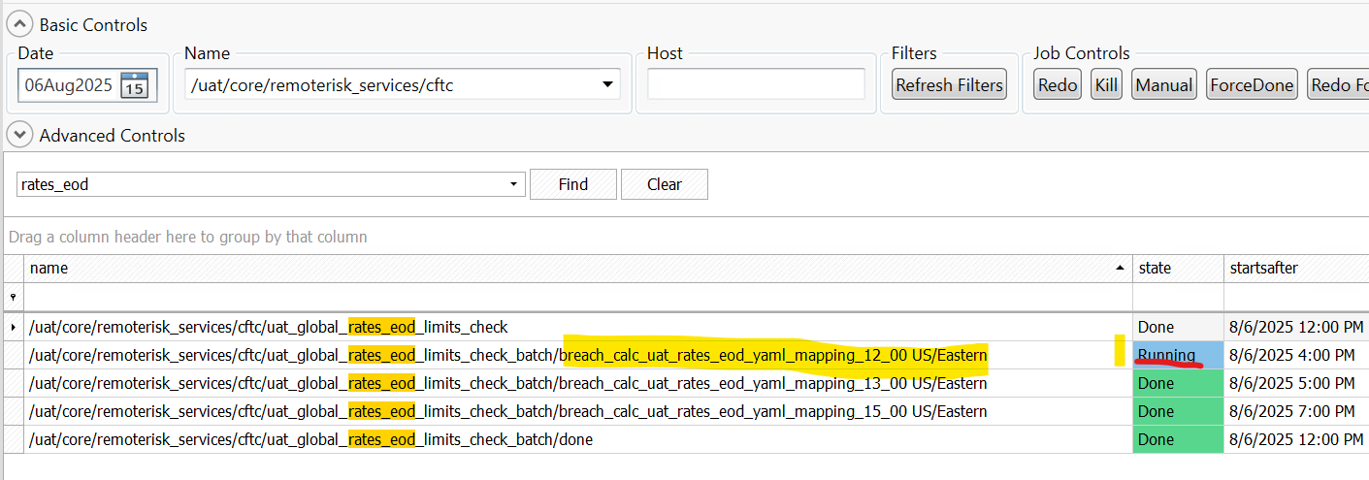

All VTD Exposure Details xls attachments present –

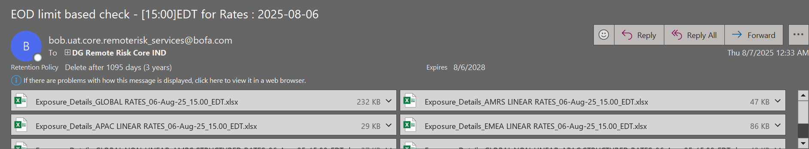

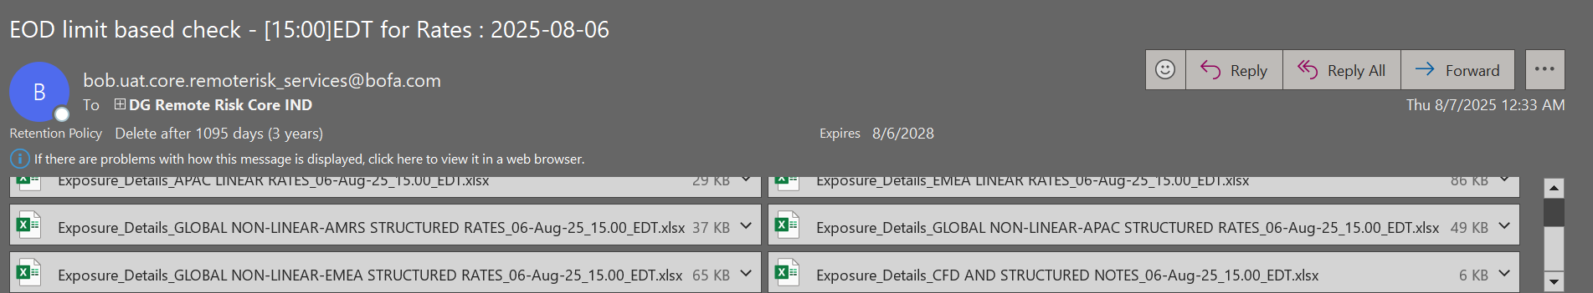

Exposure Data *VTD wise* –

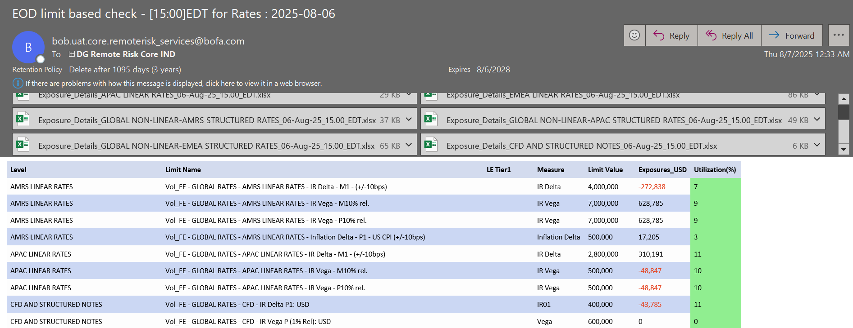

* 1. **Specifically check for GNLR AMRS VTD as it has data from multiple sources.**

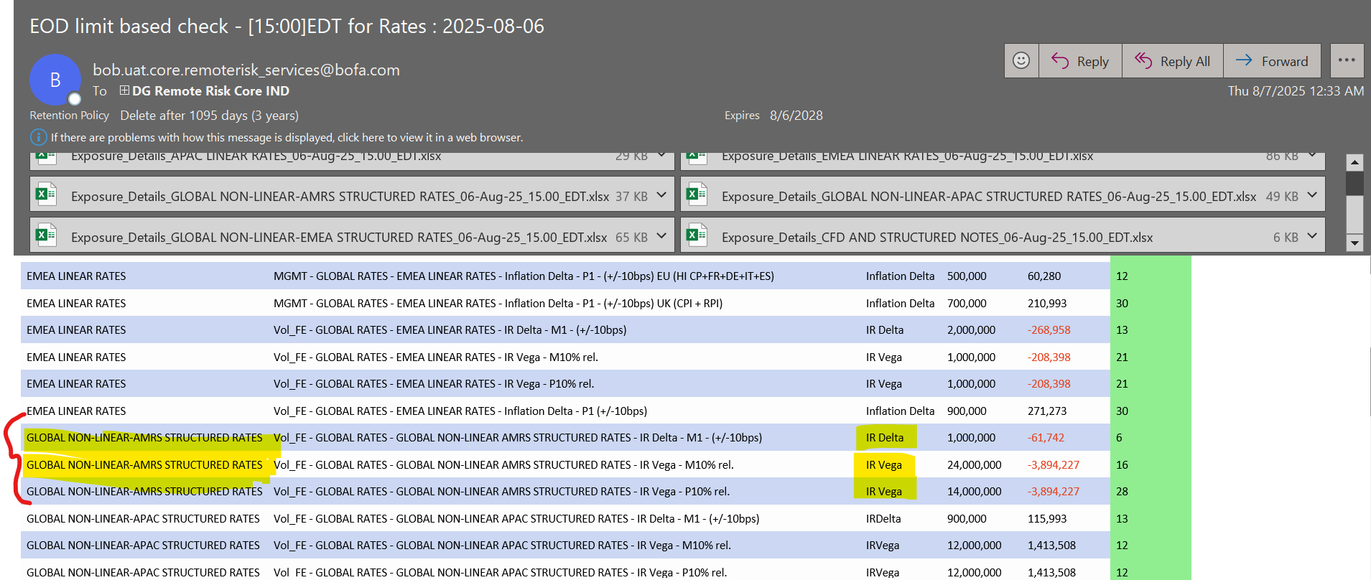

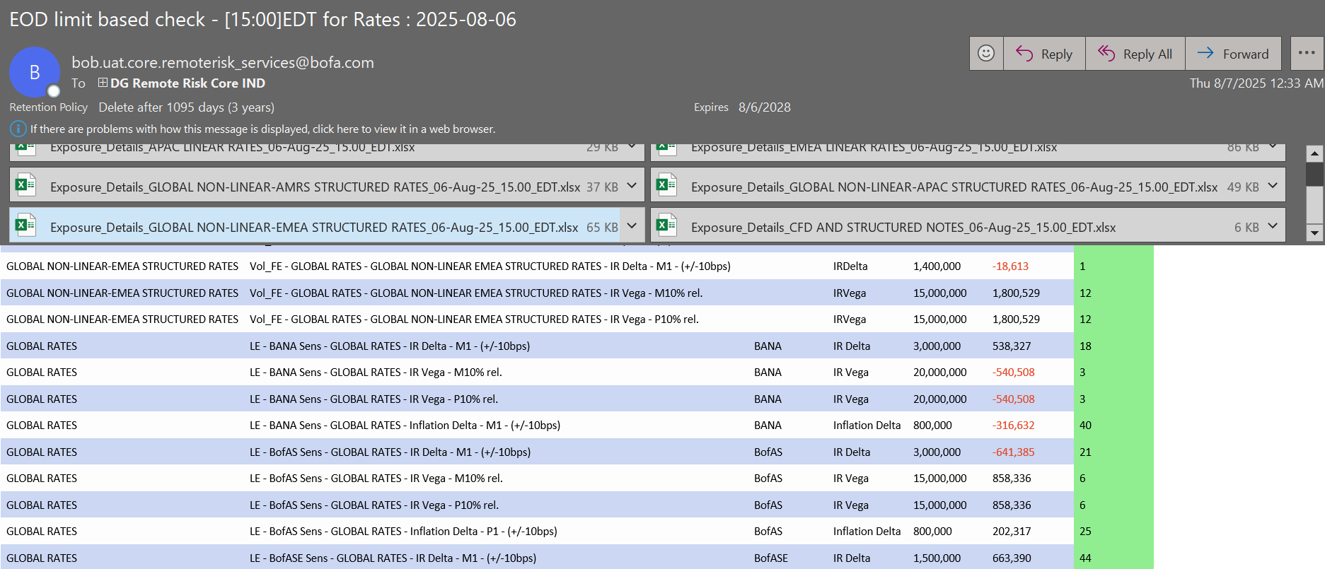

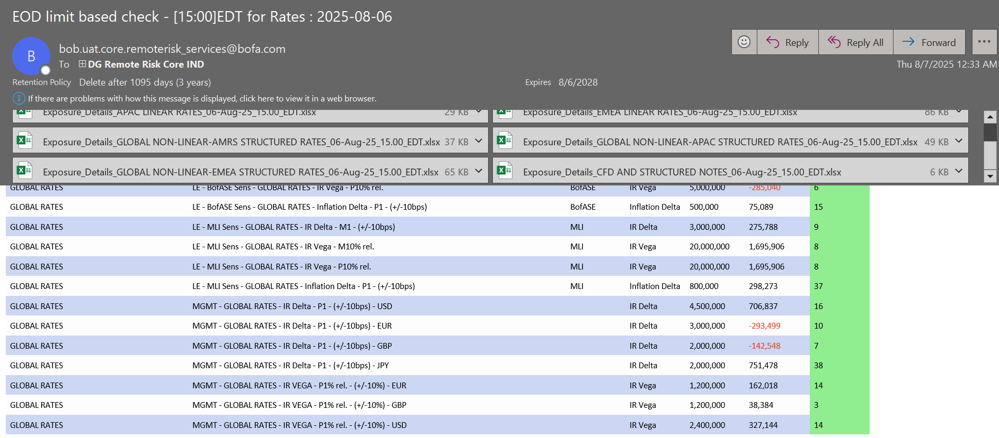

1. One VTD - all measures missing data

All the below scenarios - check if attachments are coming as expected – attachment for missing VTD shouldn’t be available

1. First VTD has missing data and next VTDs are working as expected
2. Last VTD has missing data and other VTDs are working as expected
3. Second VTD has missing data and first and last VTDs are working as expected